EDUFLOW

PROJECT REPORT
Submitted partial fulfillment of the requirements
for the award of the degree of

Bachelor of Computer Applications (BCA)

Submitted by
VINODH KUMAR P
2313141033090

Under the guidance of

Dr. M. T. RAGHURAMAN MCA., M.Phil., B.Ed., Ph.D.,
ASSISTANT PROFESSOR
BACHELOR OF COMPUTER APPLICATIONS



GURU NANAK COLLEGE (AUTONOMOUS)
A Sikh Minority Institution | Unit of Guru Nanak Educational Society (Regd.)
Affiliated to University of Madras | Accredited at ‘A++’ Grade by NAAC | Approved by AICTE
Guru Nanak Salai, Velachery, Chennai – 600 042.

MARCH – 2026


GURU NANAK COLLEGE (AUTONOMOUS)
A Sikh Minority Institution | Unit of Guru Nanak Educational Society(Regd.)
Affiliated to University of Madras | Accredited at ‘A++’ Grade by NAAC | Approved by AICTE
Guru Nanak Salai, Velachery, Chennai – 600 042.

School of Information Technology
Bachelor of Computer Applications (BCA)

BONAFIDE CERTIFICATE
This is to certify that the project report is a Bonafide record of work done by
VINODH KUMAR P, 2313141033090 for the Final Year Project during the Academic Year 2025-26.

PROJECT GUIDE HEAD OF THE PROGRAMME

Submitted for the Project Viva Voce Examination held on ________________ at Guru Nanak College (Autonomous), Guru Nanak Salai, Velachery, Chennai - 600 042.

Internal Examiner External Examiner
Date: Date:

DECLARATION

I VINODHKUMAR P 2313141033090 studying III Year BCA at Guru Nanak College (Autonomous), Chennai hereby declare that the report of my Project entitled, EDUFLOW is the record of the original work carried out by me under the Guidance and Supervision of Dr. M. T. RAGHURAMAN towards the partial fulfillment of the requirements of the award of the Degree of BACHELOR OF COMPUTER APPLICATIONS
I further declare that this has not been submitted anywhere for the award of Degree / Diploma or any other similar to this before.

PLACE: CHENNAI VINODH KUMAR P
DATE: 2313141033090

ACKNOWLEDGEMENT
I would like to express my sincere gratitude to the Principal, Dr. R. M. Ezhilarasi, and the Vice Principal, Dr. P. V. Kumaraguru, Guru Nanak College (Autonomous), for providing the necessary facilities, resources, and academic environment for the successful completion of this project.
I extend my heartfelt thanks to Dr. S. Nirmala Devi, Dean, for her constant support, encouragement, and academic guidance throughout the course of this project.
I express my sincere gratitude to Dr. R. Caroline Kalaiselvi, Head of the Department, Bachelor of Computer Applications, for her valuable guidance, motivation, and continuous support during the development of this project.
I also thank Dr. M. T. Raghuraman, Assistant Professor, Department of Bachelor of Computer Applications, for his guidance, encouragement, and constructive suggestions which contributed significantly to this work.
I extend my appreciation to all the Faculty members of the BCA Department for their academic support and valuable inputs during the course of this study.
Finally, I thank my parents and friends for their unwavering encouragement and support, which enabled me to complete this project successfully.

ABSTRACT
EduFlow is a web-based School Enterprise Resource Planning (ERP) system developed to digitize and streamline academic and administrative operations within educational institutions. The system centralizes key academic processes such as student admissions, homework management, assignment submission, and parent monitoring into a single integrated platform.
Traditional school management systems often rely on manual record-keeping and fragmented communication methods, leading to inefficiency, data redundancy, and lack of transparency. EduFlow addresses these challenges by implementing a structured, role-based ERP solution using the Django framework. The system provides separate dashboards for administrators, teachers, students, and parents, ensuring controlled access and secure data management.

The application follows the Model-View-Template architecture and integrates database-driven workflows to manage academic records effectively. It supports file uploads for assignments, structured database storage, and controlled access through authentication mechanisms. The platform enhances communication between stakeholders and improves operational efficiency.EduFlow demonstrates how a scalable web-based ERP architecture can modernize school management through automation, data integrity, and centralized control.

TABLE OF CONTENTS
S.No. | Topic | Page No.
1 | INTRODUCTION | 1
2 | METHODOLOGY  2.1 SYSTEM OVERVIEW  2.2 PROBLEM IDENTIFICATION  2.3 REQUIREMENT ANALYSIS  2.4 SYSTEM ARCHITECTURE  2.5 DATABASE DESIGN  2.6 MODULE DESIGN | 4
3 | MODEL / SYSTEM SELECTION  3.1 DJANGO MVT ARCHITECTURE  3.2 ROLE-BASED ACCESS CONTROL MODEL | 19
4 | SYSTEM BUILDING AND IMPLEMENTATION  4.1 FRONTEND DEVELOPMENT  4.2 BACKEND DEVELOPMENT  4.3 DATABASE IMPLEMENTATION  4.4 FILE UPLOAD AND MANAGEMENT SYSTEM | 25
5 | PROJECT REQUIREMENTS  5.1 HARDWARE REQUIREMENTS  5.2 SOFTWARE REQUIREMENTS  5.3 DEVELOPMENT ENVIRONMENT | 36
6 | WORKFLOW DIAGRAM | 43
7 | SOURCE CODING | 46
8 | SYSTEM DESIGN  8.1 ER DIAGRAM  8.2 DATA FLOW DIAGRAM  8.3 USE CASE DIAGRAM | 52
9 | SCREEN LAYOUTS | 62
10 | TESTING AND VALIDATION | 73
11 | CONCLUSION | 78
12 | REFERENCES | 81

INTRODUCTION

- INTRODUCTION
The rapid advancement of information technology has significantly transformed the way organizations manage operations and data. Educational institutions, in particular, require efficient systems to handle academic processes, student records, communication channels, and administrative tasks. Traditional methods of school management often involve manual record keeping, physical documentation, and fragmented communication systems. These practices result in inefficiencies, data inconsistency, lack of transparency, and increased administrative workload.
Enterprise Resource Planning (ERP) systems are integrated software platforms designed to manage and automate core organizational processes through a centralized database and structured workflows. In the educational domain, a School ERP system unifies academic, administrative, and communication functions under a single digital framework. Such systems enhance coordination among administrators, teachers, students, and parents while ensuring data integrity and accessibility.
EduFlow is a web-based School ERP system developed to digitize and streamline institutional operations. The system focuses on core academic management functionalities including student admissions, homework creation, assignment submission, role-based dashboards, and parent monitoring. EduFlow is designed to provide structured access control, centralized data storage, and automated workflow management.
The application is developed using the Django web framework, which follows the Model-View-Template architectural pattern. This architecture ensures modular development, maintainability, and scalability. The backend handles data processing, authentication, and database operations, while the frontend provides a responsive and user-friendly interface.
EduFlow addresses several operational challenges faced by educational institutions:
- Inefficient manual paperwork.
- Lack of centralized academic tracking
- Limited communication between teachers and parents
- Difficulty in monitoring student submissions
- Absence of structured role-based access control
By implementing a centralized ERP solution, EduFlow enables:
- Secure user authentication
- Role-based dashboards for Admin, Teacher, Student, and Parent
- Structured homework management
- File upload and submission tracking
- Transparent academic monitoring
The system ensures data consistency through relational database design and enforces access control using Django’s authentication framework. Each user role has clearly defined permissions, preventing unauthorized access and maintaining system security.
EduFlow is designed with scalability in mind. The system is implemented using MySQL as the primary relational database management system. The architecture supports migration to enterprise-grade database environments for large-scale institutional deployment.
This project demonstrates the practical implementation of a web-based ERP architecture tailored for educational institutions. It emphasizes system design principles, database modeling, workflow automation, and secure application development. EduFlow serves as a foundational framework for transforming traditional academic administration into a structured, efficient, and technology-driven ecosystem.

METHODOLOGY

- METHODOLOGY
The methodology of the EduFlow project defines the structured approach followed to design, develop, and implement the School ERP system. The development process emphasizes modular design, database-driven architecture, secure authentication mechanisms, and role-based workflow management.
The system is developed using a layered architectural approach. The frontend layer handles user interaction and presentation. The backend layer manages business logic, authentication, and data processing. The database layer ensures structured data storage and relational integrity.
The development methodology includes the following phases:
- Requirement Analysis
- System Design
- Database Modeling
- Module Development
- Integration and Testing
- Deployment Preparation
Each phase is executed systematically to ensure consistency, maintainability, and scalability of the system.
2.1 SYSTEM OVERVIEW
EduFlow is a web-based School Enterprise Resource Planning system designed to centralize and automate academic and administrative operations. The system provides structured access to different stakeholders including administrators, teachers, students, and parents.
The core objective of the system is to replace manual record management with a digital workflow-driven platform. EduFlow integrates multiple academic functions into a single centralized database system.
The system consists of the following primary components:
User Management Module
This module handles user registration, authentication, and role assignment. It ensures secure login and access control based on user roles.
Admissions Module
This module manages student admission applications. It stores applicant details and allows administrative approval or rejection.
Academics Module
This module enables teachers to create homework assignments and students to submit responses. It supports file uploads and structured submission tracking.
Parent Monitoring Module
This module allows parents to monitor their child’s academic progress and homework submission status.
Role-Based Access Control
Each user is assigned a specific role. The system restricts access to functionalities based on permissions associated with that role. This ensures data confidentiality and operational control.
The system architecture follows the Model-View-Template pattern:
Model
Defines database structure and relationships.
View
Handles request processing and business logic.
Template
Manages user interface presentation.
EduFlow operates in a client-server environment. Users access the system through a web browser. The server processes requests and interacts with the database to return structured responses.
The system ensures:
- Centralized data management
- Secure authentication
- Controlled access permissions
- Organized workflow structure
- Scalable architecture
EduFlow is designed to be extendable. Additional modules such as attendance tracking, fee management, and notification systems can be integrated without altering the core architecture.
  - PROBLEM IDENTIFICATION
Educational institutions often rely on manual administrative processes and disconnected systems to manage academic activities. These traditional methods create operational inefficiencies and increase the risk of data errors.
The primary problems identified in conventional school management systems are as follows:
Manual Record Management
Student records, homework tracking, and admission details are often maintained on paper or in unstructured digital files. This leads to duplication of data, difficulty in retrieval, and increased administrative workload.
Lack of Centralized System
Different departments manage data independently without integration. This results in poor coordination between teachers, administrators, and parents.
Inefficient Communication
Communication between teachers and parents is often limited to periodic meetings or informal messaging. There is no structured digital platform to monitor academic progress in real time.
Poor Homework Tracking
Students submit assignments physically, making it difficult to track submission history, deadlines, and evaluation records. Teachers face challenges in organizing and reviewing submissions efficiently.
Limited Role-Based Access
Traditional systems do not implement structured role-based permissions. Sensitive data may be accessed without proper control, leading to security risks.
Data Inconsistency and Redundancy
Without a centralized database, the same data may be stored in multiple locations. This creates inconsistencies and increases the risk of data loss.
Scalability Issues
Manual systems cannot efficiently handle growth in student numbers or academic activities. As institutions expand, administrative complexity increases.
These identified problems highlight the need for a structured, centralized, and secure ERP solution. EduFlow is designed specifically to address these operational gaps by introducing automation, database-driven workflows, and controlled access mechanisms.
2.3 REQUIREMENT ANALYSIS
Requirement analysis defines the functional and non-functional expectations of the EduFlow system. This phase ensures that the system design aligns with institutional needs and operational objectives.
Requirements are categorized into Functional Requirements and Non-Functional Requirements.
Functional Requirements
Functional requirements describe the core operations the system must perform.
User Authentication
- The system must allow user registration and login.
- The system must support role-based access for Admin, Teacher, Student, and Parent.
- The system must restrict unauthorized access.
Admission Management
- The system must allow submission of student admission applications.
- The Admin must be able to approve or reject applications.
- Admission status must be stored in the database.
Homework Management
  - Teachers must be able to create homework assignments.
  - Homework details must include title, description, deadline, and file attachments if required.
  - Students must be able to view assigned homework.
Assignment Submission
- Students must be able to upload assignment files.
- The system must store submission records linked to both student and homework
- Students must be able to delete incorrect uploads before deadline.
Parent Monitoring
- Parents must be able to view their child’s academic records.
- Parents must see homework and submission status.
Dashboard Management
- Each role must have a separate dashboard.
- The dashboard must display relevant information based on permissions.
Database Operations
- The system must store data in relational format.
- Data retrieval must be efficient and structured.
Non-Functional Requirements
Non-functional requirements define system quality attributes.
Security
- The system must implement secure authentication.
- Sensitive data must be protected using role-based access control.
- CSRF protection must be enabled.
Performance
- The system must handle multiple user requests efficiently.
- Database queries must be optimized.
Scalability
- The system must support migration to advanced databases such as PostgreSQL.
- The architecture must allow additional modules in future.
Usability
- The interface must be responsive and user-friendly.
- Navigation must be simple and structured.
Maintainability
- The system must follow modular coding standards.
- Code must be reusable and easy to extend.
Reliability
- Data must remain consistent and protected from accidental loss.
- File uploads must be securely handled.
  - SYSTEM ARCHITECTURE
EduFlow follows a web-based client-server architecture built using the Django framework. The system is structured using the Model–View–Template architectural pattern. This approach separates data handling, business logic, and presentation layers to ensure modularity and maintainability.
The architecture consists of three primary layers:
Presentation Layer
This layer manages user interaction. It includes HTML templates, Bootstrap-based UI components, and responsive layouts. Users access the system through a web browser.
Application Layer
This layer processes requests, executes business logic, and controls workflow management. It is implemented using Django views and middleware components.
Database Layer
This layer stores and manages structured data using MySQL. All academic records, user details, homework information, and submissions are maintained in relational tables.
The system operates using a request-response cycle:
- User sends request through browser
- Django View processes request
- Model interacts with MySQL database
- Processed data is returned to Template
- HTML response is rendered to user
The architecture ensures:
- Centralized data management
- Secure role-based access
- Modular system design
- Scalability for future expansion
SYSTEM ARCHITECTURE DIAGRAM
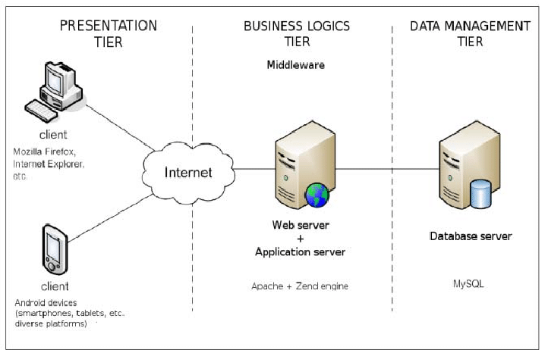

  - DATABASE DESIGN
The EduFlow system uses MySQL as the relational database management system. MySQL ensures structured storage, data integrity, and efficient query execution. The database is designed using relational modeling principles, where entities are represented as tables and relationships are maintained using primary and foreign keys.
The database design follows normalization principles to eliminate redundancy and maintain consistency. Each table stores data related to a specific entity, and relationships are defined using foreign key constraints.
Primary Entities in EduFlow
- User
Stores authentication and role information.
Important Fields:
- id (Primary Key)
- username
- email
- password
- role (Admin, Teacher, Student, Parent)
- Admission Application
Stores student admission details.
Important Fields:
- id (Primary Key)
- student_name
- date_of_birth
- contact_details
- status (Pending, Approved, Rejected)
- created_at
- Homework
Stores assignments created by teachers.
Important Fields:
- id (Primary Key)
- title
- description
- deadline
- teacher_id (Foreign Key → User)
- created_at
- Submission
Stores student assignment submissions.
Important Fields:
- id (Primary Key)
- homework_id (Foreign Key → Homework)
- student_id (Foreign Key → User)
- file_upload
- submitted_at
Relational Structure
- One Teacher can create many Homework records.
- One Homework can have many Submissions.
- One Student can submit many Submissions.
- Each Submission belongs to one Homework and one Student.
This relational design ensures:
- Data integrity
- Efficient querying
- Reduced redundancy
- Structured academic tracking

DATABASE DESIGN DIAGRAM
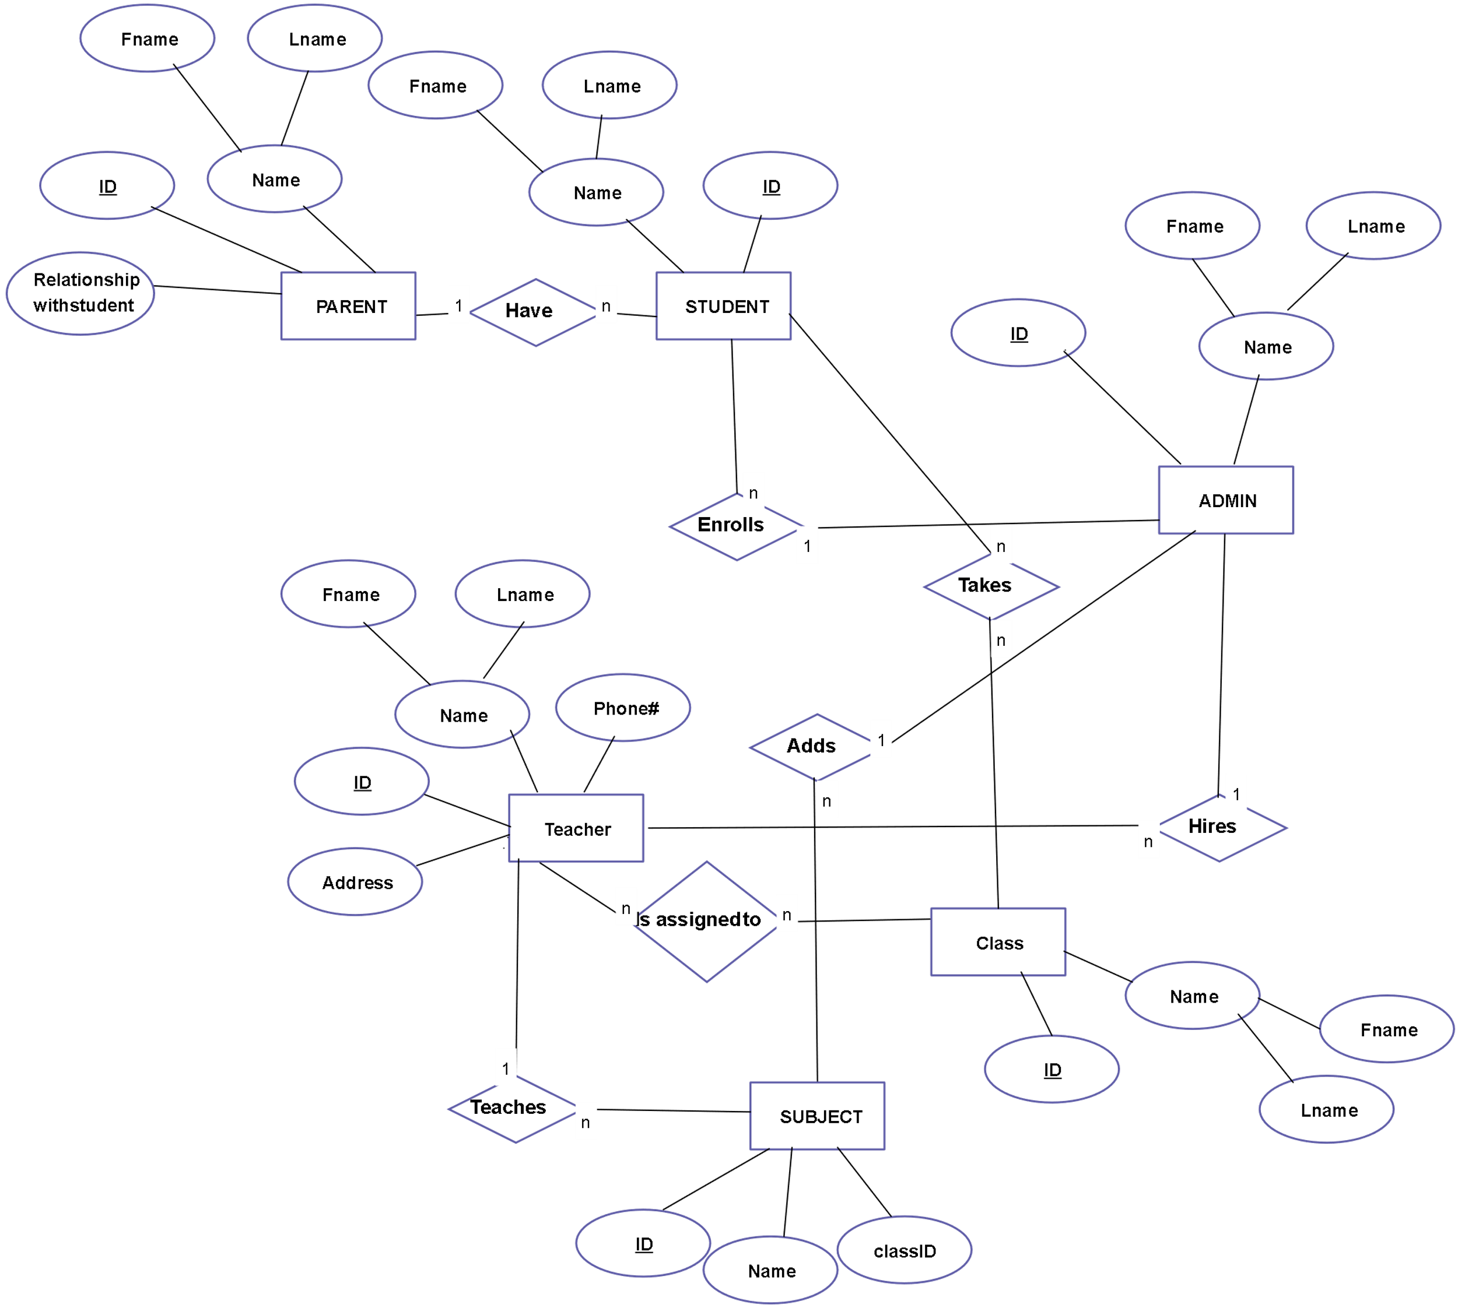
  - MODULE DESIGN
The EduFlow system is divided into independent functional modules. Each module is responsible for handling a specific set of operations. The modular structure improves maintainability, scalability, and code organization.
The major modules of the system are described below.
- Accounts Module
This module manages user authentication and role-based access control.
Functions:
- User registration
- Secure login and logout
- Role assignment
- Password protection
- Session management
Each user is assigned one of the following roles:
- Admin
- Teacher
- Student
- Parent
Based on the assigned role, the system dynamically loads the appropriate dashboard and restricts unauthorized access.
Security Mechanisms Used:
- Django authentication system
- Encrypted password storage
- CSRF protection
- Role-based permission validation
- Admissions Module
This module manages the student admission process.
Functions:
- Admission form submission
- Data storage in MySQL
- Status tracking
- Approval or rejection by Admin
Workflow:
- Applicant fills admission form
- Data stored in database
- Admin reviews application
- Status updated (Pending / Approved / Rejected)
This module ensures structured handling of admission data.
- Academics Module
This is the core functional module of EduFlow.
Homework Management:
- Teachers create assignments
- Deadline specification
- Description and file attachment
Submission Management:
- Students upload assignment files
- File linked to specific homework
- Submission timestamp stored
- Students can delete incorrect upload before deadline
Teacher Controls:
- View submissions
- Download files
- Track submission history
All submission records are stored using foreign key relationships to maintain referential integrity.
- Parent Monitoring Module
This module provides transparency in academic tracking.
Functions:
- View child dashboard
- Monitor homework status
- Track submission records
- Observe academic progress
Parents have read-only access and cannot modify records.
MODULE INTERACTION DIAGRAM
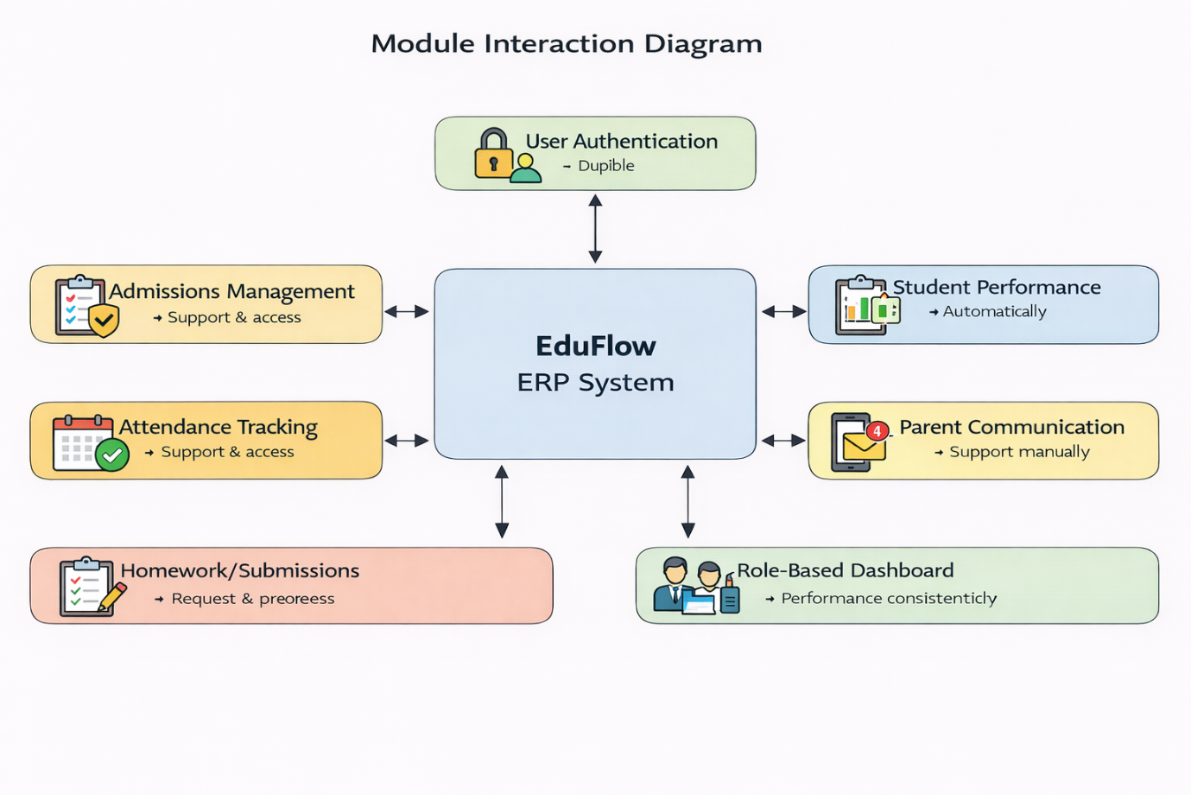

MODEL / SYSTEM SELECTION

- MODEL / SYSTEM SELECTION
Model selection defines the architectural and access control framework used to build EduFlow. The system is designed using a structured web application architecture to ensure modularity, scalability, and secure access management.
EduFlow adopts two major models:
- Django MVT Architecture
- Role-Based Access Control Model
3.1 DJANGO MVT ARCHITECTURE
EduFlow is developed using the Django framework, which follows the Model–View–Template architectural pattern. This architecture ensures separation of concerns between data management, business logic, and presentation.
Model
The Model represents the database structure. It defines tables, fields, relationships, and constraints. In EduFlow, models are used to define entities such as:
- User
- AdmissionApplication
- Homework
- Submission
The Model layer interacts directly with the MySQL database to store and retrieve structured data.
View
The View processes HTTP requests and implements business logic. It performs tasks such as:
- Validating user authentication
- Fetching records from the database
- Processing form submissions
- Handling file uploads
The View connects the Model and Template layers.
Template
The Template handles presentation logic. It displays dynamic content using HTML and Bootstrap styling. Templates render data sent from the View and generate the final user interface.
MVT Request-Response Flow
- User sends request through browser
- Django URL routes request to View
- View interacts with Model
- Model queries MySQL database
- Data returned to View
- View sends context to Template
- Template renders HTML response
This architecture ensures:
- Code modularity
- Maintainability
- Scalability
- Clear separation of responsibilities

Django MVT Architecture Diagram
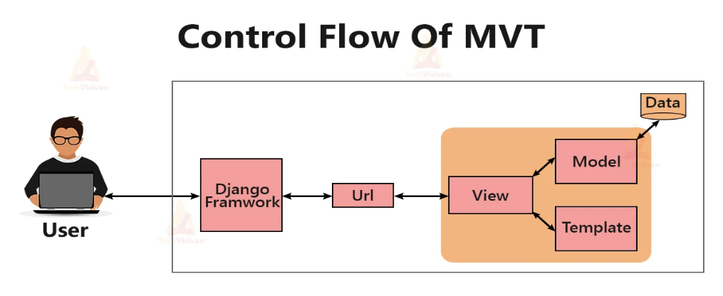
3.2 ROLE-BASED ACCESS CONTROL MODEL
EduFlow implements a Role-Based Access Control system to ensure secure and structured user permissions.
In this model, access rights are assigned based on user roles rather than individual users. Each role has predefined permissions that restrict system operations and protect sensitive data.
Roles in EduFlow
Admin
- Full system configuration control
- Manage user accounts
- Approve or reject admissions
- Monitor overall system activity
- Database-level supervision
Principal
- Academic supervisory authority
- View all teacher activities
- Monitor homework and submissions
- Access institutional performance data
- View admission statistics
- Generate academic reports
Teacher
- Create homework
- Edit or delete homework before deadline
- View student submissions
- Download assignment files
Student
- View assigned homework
- Submit assignments
- Delete incorrect submissions before deadline
Parent
- View child academic status
- Monitor homework submissions
- Track performance records
Access Control Mechanism
- User logs in with credentials
- System authenticates using Django authentication
- Role field is validated from MySQL database
- Permissions are dynamically assigned
- Unauthorized requests are denied
- Access to restricted URLs is blocked

Hierarchical Structure
Admin
↑
Principal
↑
Teacher
↑
Student
↑
Parent
The Principal role has supervisory visibility but does not directly manage database configurations unless explicitly permitted.

SYSTEM BUILDING AND IMPLEMENTATION

- SYSTEM BUILDING AND IMPLEMENTATION
This section explains how EduFlow was practically developed and integrated using Django, MySQL, and frontend technologies. It describes the implementation process of each technical component.
4.1 FRONTEND DEVELOPMENT
The frontend of EduFlow is responsible for user interaction and interface presentation. It is designed to provide a clean, responsive, and structured user experience.
Technologies Used
- HTML5
- CSS3
- Bootstrap 5
- Django Template Engine
Design Approach
The frontend follows a modern SaaS-based layout structure with:
- Responsive navigation bar
- Dashboard-based layout
- Card-based content structure
- Table-based academic records
- Form-based data input
- Soft UI components with clean typography
Responsive Design
Bootstrap 5 grid system is used to ensure responsiveness across devices such as:
  - Desktop
  - Laptop
  - Tablet
  - Mobile
Forms and Validation
Forms are implemented using Django Forms and rendered in templates. Validation is handled in two stages:
- Client-side validation using HTML attributes
- Server-side validation using Django Form validation
User Interface Components
Dashboard
Each role has a dedicated dashboard with:
  - Quick access buttons
  - Statistics overview
  - Navigation links
Tables
Tables are used for:
  - Homework listing
  - Submission records
  - Admission applications
  - User management
Cards
Cards are used for structured data display such as:
    - Homework details
    - Admission summary
    - tudent overview
Upload Interface
File upload functionality is integrated into submission forms. The interface allows students to select files and upload securely to the server.
Frontend Workflow
- User logs in
- System loads role-specific dashboard
- User selects module
- Form or table is rendered
- User submits data
- Backend processes request
The frontend communicates dynamically with backend views to fetch and render database content.
4.2 BACKEND DEVELOPMENT
The backend of EduFlow is developed using the Django web framework. It is responsible for handling business logic, processing user requests, managing authentication, and interacting with the MySQL database.
Framework Used
  - Django
  - Python
Backend Architecture
The backend follows Django’s Model–View–Template structure. The core components implemented during development are:

Models
Models define database tables and relationships. Each entity such as User, Homework, Submission, and AdmissionApplication is implemented as a Django model. These models map directly to MySQL tables.
Views
Views handle HTTP requests and implement application logic. They perform operations such as:
    - Validating user login
    - Fetching homework records
    - Processing admission forms
    - Handling file uploads
    - Saving submission data
URL Routing
Django’s URL dispatcher maps user requests to corresponding view functions. Each module has dedicated URL patterns to maintain structured navigation.
Authentication System
Django’s built-in authentication framework is used for:
    - User login and logout
    - Password encryption
    - Session handling
    - Role validation
When a user logs in:
- Credentials are verified
- Session is created
- Role is checked
- Dashboard is loaded accordingly
Middleware
Middleware components handle request filtering, authentication validation, and security checks before processing each request.
File Handling System
The backend implements secure file upload handling for assignment submissions.
Process:
  - Student selects file
  - File is sent through POST request
  - Django stores file in media directory
  - File path is stored in MySQL database
  - Teacher can download file securely
Security Controls
  - CSRF protection enabled
  - Role-based permission checks
  - Restricted URL access
  - Secure password hashing
Error Handling
The backend includes validation mechanisms to:
    - Prevent invalid form submissions
    - Handle missing records
    - Restrict unauthorized access attempts

4.3 DATABASE IMPLEMENTATION
The EduFlow system uses MySQL as the relational database management system for storing and managing structured data. MySQL ensures high performance, data integrity, and efficient query execution for academic and administrative records.
Database Configuration
The MySQL database is connected to the Django application using the Django database configuration settings.
The configuration includes:
  - Database Engine: MySQL
  - Database Name: eduflow_db
  - Username and Password
  - Host and Port configuration
Django ORM is used to interact with MySQL without writing raw SQL queries. The ORM converts Python model definitions into SQL tables automatically.
Table Creation
Database tables are generated using Django migrations.
Process followed:
- Models are defined in models.py
- makemigrations command generates migration files
- migrate command creates tables in MySQL
Each model corresponds to a database table.
Primary Key Implementation
Every table contains a primary key field. This ensures uniqueness of records.

Example:
    - user_id
    - homework_id
    - submission_id
    - admission_id
Foreign Key Constraints
Relationships between tables are implemented using foreign keys.
Examples:
  - Homework → teacher_id references User
  - Submission → homework_id references Homework
  - Submission → student_id references User
These constraints enforce referential integrity. A submission cannot exist without a valid homework and student reference.
Data Normalization
The database design follows normalization principles to:
    - Eliminate redundant data
    - Maintain consistency
    - Improve data reliability
Each entity is stored in a separate table and linked through relationships.
Indexing
Primary keys are automatically indexed. This improves query performance when retrieving:
    - Homework records
    - Submission lists
    - User details
Data Storage Structure
The system stores:
    - User credentials
    - Admission details
    - Homework records
    - Assignment file paths
    - Submission timestamps
Actual uploaded files are stored in the media directory on the server. Only the file path is stored in the MySQL database.
Data Integrity Mechanisms
  - Foreign key constraints
  - Required field validation
  - Unique constraints
  - Controlled deletion policies
4.4 FILE UPLOAD AND MANAGEMENT SYSTEM
The File Upload and Management System in EduFlow enables students to submit assignments digitally and allows teachers to access and review submitted files. This module ensures secure handling, structured storage, and controlled access to uploaded documents.

File Upload Workflow
The file upload process follows a secure request–response mechanism.
Step 1
Student selects assignment file using submission form.
Step 2
File is sent to the server using an HTTP POST request with multipart form data.
Step 3
Django processes the request in the corresponding view function.
Step 4
The file is stored in the server’s media directory.
Step 5
The file path is saved in the MySQL database under the Submission table.
Step 6
Teacher accesses submission records and downloads files when required.
Media Storage Configuration
The system defines a dedicated media directory for storing uploaded files.
Media Folder Structure Example:
media/
submissions/
student_id/
assignment_file.pdf
Only the file path is stored in the database. The actual file remains in the server directory.
File Validation Mechanisms
    - To maintain security and integrity, the system implements:
    - File size validation
    - File type validation (PDF, DOCX, etc.)
    - Authenticated user verification
    - Deadline-based submission restriction
Students cannot upload files after the specified deadline.
Access Control for Files
Role-based access is enforced:
Student
  - Upload file
  - Delete own submission before deadline
Teacher
  - View all submissions for assigned homework
  - Download student files
Admin
Database-level supervision
Security Measures
  - CSRF protection enabled
  - Secure file path storage
  - Restricted direct media access
  - Permission checks before download
  - Prevent unauthorized URL access

PROJECT REQUIREMENTS

5. PROJECT REQUIREMENTS
This section specifies the hardware and software requirements necessary for developing and deploying the EduFlow ERP system.
5.1 HARDWARE REQUIREMENTS
The hardware requirements for EduFlow are categorized into development environment requirements and deployment environment requirements.
Development Environment Requirements
Processor
  - Minimum: Intel Core i3 or equivalent
  - Recommended: Intel Core i5 or higher
RAM
  - Minimum: 4 GB
  - Recommended: 8 GB or higher
Storage
  - Minimum: 256 GB HDD
  - Recommended: 512 GB SSD
Display
  - 1366 × 768 resolution or higher
Network
  - Stable internet connection for package installation and updates

Deployment Environment Requirements
Server Processor
  - Multi-core processor
Server RAM
  - Minimum 8 GB for small-scale deployment
Storage
  - SSD recommended for better performance
Network
  - Reliable internet connectivity
  - Static IP or cloud hosting environment
Peripheral Devices
  - Keyboard
  - Mouse
  - Backup storage device
These hardware specifications ensure smooth development, testing, and execution of the EduFlow ERP system.
5.2 SOFTWARE REQUIREMENTS
The EduFlow ERP system requires a structured software environment for development, testing, and deployment. The following software components are used in the implementation of the system.

Operating System
  - Windows 10 or higher
  - Linux (Ubuntu recommended for deployment)
  - macOS (optional for development)
Programming Language
  - Python 3.x
Web Framework
  - Django
Database Management System
  - MySQL
Frontend Technologies
  - HTML5
  - CSS3
  - Bootstrap 5
  - Django Template Engine
Development Tools
  - Visual Studio Code
  - PyCharm (optional)
  - MySQL Workbench
  - Git for version control
Server Environment
  - Django Development Server (for testing)
  - Apache or Nginx (for production deployment)
Browser Compatibility
EduFlow is compatible with modern web browsers:
    - Google Chrome
    - Microsoft Edge
    - Mozilla Firefox
Additional Libraries
  - Django built-in authentication system
  - MySQL client connector
  - Bootstrap CSS framework
These software components ensure structured development, efficient database management, and responsive user interface design.
5.3 DEVELOPMENT ENVIRONMENT
The development environment defines the configuration and setup used to build and test the EduFlow ERP system before deployment.
Project Setup
The system was developed using Django within a structured project environment. A virtual environment was created to isolate dependencies and manage required packages efficiently.
Steps followed:
- Install Python
- Create virtual environment
- Install Django
- Configure MySQL database
- Create Django project and applications

Virtual Environment
A virtual environment ensures dependency isolation. Required libraries such as Django and MySQL connector are installed inside the environment without affecting global Python packages.
Project Structure
The Django project follows a modular directory structure:
eduflow/
manage.py
eduflow/ (project settings folder)
accounts/
admissions/
academics/
templates/
static/
media/
Each module contains:
  - models.py
  - views.py
  - urls.py
  - templates
Database Configuration
MySQL is configured in the Django settings file with:
  - Database name
  - Username
  - Password
  - Host
  - Port
Django ORM manages database communication without writing raw SQL queries.
Static Files Configuration
Static files include:
  - CSS files
  - JavaScript files
  - Images
These are stored in the static directory and configured in settings.py.
Media Files Configuration
Uploaded files such as student assignments are stored in the media directory. The MEDIA_ROOT and MEDIA_URL settings define file storage and access paths.
Testing Environment
The system is tested locally using Django’s development server. Functional testing is performed for:
    - Login system
    - Homework creation
    - File submission
    - Role-based access
Version Control
Git is used to track changes and maintain source code integrity.

WORKFLOW DIAGRAM

6. WORKFLOW DIAGRAM
The workflow diagram represents the operational flow of the EduFlow ERP system from user authentication to academic activity management. It illustrates how different user roles interact with the system and how data flows between modules.
Overall System Workflow
The system operates using a structured sequence of steps:
Step 1: User Authentication
- User enters login credentials
- System verifies credentials from MySQL database
- Role is identified
- Dashboard is loaded based on role
Step 2: Role-Based Navigation
- Admin accesses management modules
- Principal monitors academic activities
- Teacher manages homework
- Student views and submits assignments
- Parent monitors child performance
Step 3: Academic Operations
- Homework Creation
- Teacher creates homework
- Homework stored in database
- Visible to assigned students
Assignment Submission
- Student uploads file
- File stored in media directory
- File path stored in MySQL
- Submission record created
Monitoring and Review
  - Teacher views submissions
  - Principal monitors academic activity
  - Parent checks submission status
Step 4: Data Storage and Retrieval
- All records stored in MySQL
- System retrieves data dynamically
- Dashboard updates based on real-time records
Step 5: Access Control Validation
- Every action validated against role permissions
- Unauthorized access attempts blocked
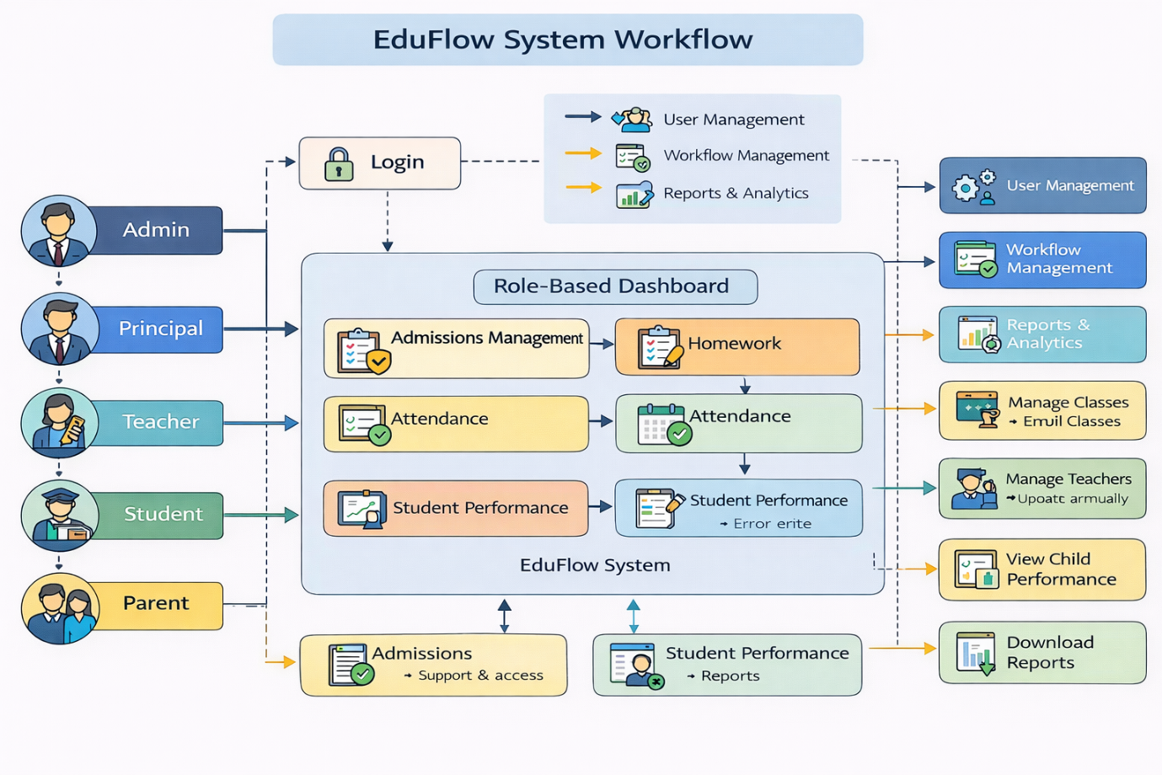

SOURCE CODING

7. SOURCE CODING
This section documents the core implementation logic of the EduFlow ERP system. It includes representative code snippets for models, views, URL configuration, database settings, and file handling. Only key components are included for documentation purposes.
7.1 MODEL IMPLEMENTATION (models.py)
User Role Model Extension
class User(AbstractUser):
ROLE_CHOICES = (
('ADMIN', 'Admin'),
('PRINCIPAL', 'Principal'),
('TEACHER', 'Teacher'),
('STUDENT', 'Student'),
('PARENT', 'Parent'),
)
role = models.CharField(max_length=20, choices=ROLE_CHOICES)
Homework Model
class Homework(models.Model):
title = models.CharField(max_length=200)
description = models.TextField()
deadline = models.DateTimeField()
teacher = models.ForeignKey(User, on_delete=models.CASCADE)
created_at = models.DateTimeField(auto_now_add=True)
Submission Model
class Submission(models.Model):
homework = models.ForeignKey(Homework, on_delete=models.CASCADE)
student = models.ForeignKey(User, on_delete=models.CASCADE)
file = models.FileField(upload_to='submissions/')
submitted_at = models.DateTimeField(auto_now_add=True)
Admission Model
class AdmissionApplication(models.Model):
student_name = models.CharField(max_length=200)
date_of_birth = models.DateField()
contact_details = models.CharField(max_length=15)
status = models.CharField(max_length=20, default='Pending')
created_at = models.DateTimeField(auto_now_add=True)
7.2 VIEW IMPLEMENTATION (views.py)
Login Role Redirection
def login_redirect(request):
if request.user.role == 'ADMIN':
return redirect('admin_dashboard')
elif request.user.role == 'PRINCIPAL':
return redirect('principal_dashboard')
elif request.user.role == 'TEACHER':
return redirect('teacher_dashboard')
elif request.user.role == 'STUDENT':
return redirect('student_dashboard')
elif request.user.role == 'PARENT':
return redirect('parent_dashboard')
Homework Creation View
@login_required
def create_homework(request):
if request.user.role == 'TEACHER':
if request.method == 'POST':
title = request.POST['title']
deadline = request.POST['deadline']
Homework.objects.create(
title=title,
deadline=deadline,
teacher=request.user)
return redirect('teacher_dashboard')
return render(request, 'create_homework.html')
Submission Upload View
@login_required
def submit_assignment(request, homework_id):
homework = Homework.objects.get(id=homework_id)
if request.method == 'POST':
file = request.FILES['file']
Submission.objects.create(
homework=homework,
student=request.user,
file=file
)
return redirect('student_dashboard')
return render(request, 'submit_assignment.html', {'homework': homework})
7.3 URL CONFIGURATION (urls.py)
from django.urls import path
from . import views
urlpatterns = [
path('create-homework/', views.create_homework, name='create_homework'),
path('submit/int:homework_id/', views.submit_assignment, name='submit_assignment'),
]
7.4 DATABASE SETTINGS (settings.py)
DATABASES = {
'default': {
'ENGINE': 'django.db.backends.mysql',
'NAME': 'eduflow_db',
'USER': 'root',
'PASSWORD': '1075',
'HOST': 'localhost',
'PORT': '3306',
}
}
7.5 FILE HANDLING SETTINGS (settings.py)
MEDIA_URL = '/media/'
MEDIA_ROOT = os.path.join(BASE_DIR, 'media')
Explanation
- Models define MySQL tables
- Views handle business logic
- URLs map requests
- Settings connect Django to MySQL
- File uploads stored in media directory
- ORM manages SQL operations automatically

SYSTEM DESIGN

8. SYSTEM DESIGN
8.1 ER DIAGRAM
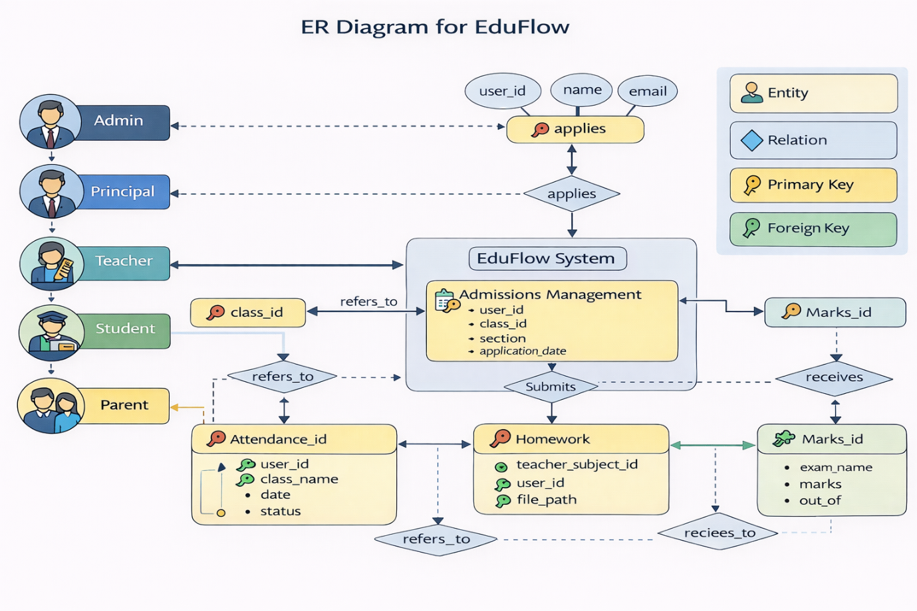
8.2 DATA FLOW DIAGRAM
The Data Flow Diagram represents how data moves within the EduFlow ERP system. It illustrates how external users interact with the system and how information is processed and stored in the MySQL database.
The DFD is explained in two levels:
- Level 0 – Context Diagram
- Level 1 – Detailed Data Flow
DFD Level 0 – Context Diagram
The Context Diagram shows EduFlow as a single system entity interacting with external users.
External Entities:
- Admin
- Principal
- Teacher
- Student
- Parent
All users send requests to the EduFlow System.
The system processes requests and interacts with the MySQL Database.
Processed responses are returned to users.

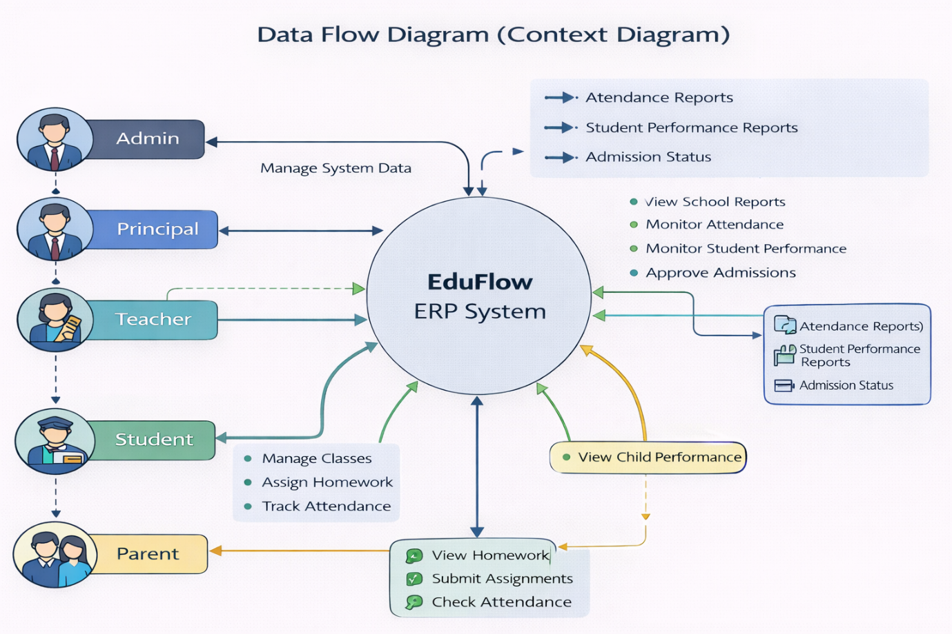DFD Level 1 – Detailed Data Flow
The Level 1 Data Flow Diagram provides a detailed representation of internal system processes in the EduFlow ERP system. Unlike Level 0, which shows the system as a single entity, Level 1 decomposes the system into major functional processes and data stores.
The main processes identified in EduFlow are:
- User Authentication
- User & Admission Management
- Academic Supervision
- Homework Management
- Assignment Submission
- User Authentication Process
Input:
  - Login credentials (username and password)
Process:
  - System validates credentials using MySQL database
  - Role is identified
  - Access permissions assigned
Output:
  - Verified session
  - Role-based dashboard access
Data Store Used:
  - User Table
- User & Admission Management
Handled primarily by Admin.
Input:
  - User registration data
  - Admission form data
Process:
- Store user information
- Approve or reject admission applications
- Update admission status
Output:
- Updated user records
- Admission status notification
Data Store Used:
- User Table
- AdmissionApplication Table
- Academic Supervision
Handled by Principal.
Input:
- Academic records
- Homework activity
Process:
- Monitor teacher activities
- Analyze performance trends
Output:
- Academic performance overview
Data Store Used:
- Homework Table
- Submission Table
- Homework Management
Handled by Teacher.
Input:
  - Homework title
  - Description
  - Deadline
Process:
- Store homework details
- Link homework to teacher
- Make homework visible to students
Output:
- Homework record
Data Store Used:
- Homework Table
- Assignment Submission
Handled by Student.
Input:
  - Assignment file
Process:
  - Upload file to media directory
  - Store file path in database
  - Link submission to homework and student
Output:
- Submission confirmation
Data Store Used:
- Submission Table
- Media Storage
Data Stores in Level 1 DFD
D1 – User Data
D2 – Admission Data
D3 – Homework Data
D4 – Submission Data
D5 – Media File Storage
Data Flow Summary
- Login credentials flow to Authentication Process
- Verified users interact with system modules
- Teachers send homework data to database
- Students send submission data to database
- Parents retrieve performance data
- Principal monitors academic data
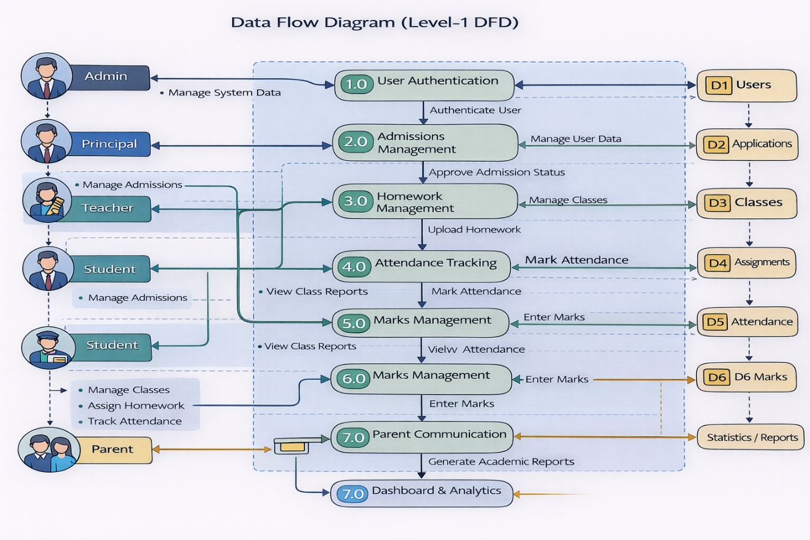
8.3 USE CASE DIAGRAM
The Use Case Diagram represents the functional interactions between system users (actors) and the EduFlow ERP system. It defines what actions each role can perform within the system.
Actors in EduFlow
- Admin
- Principal
- Teacher
- Student
- Parent
Each actor interacts with specific use cases based on assigned permissions.
Admin Use Cases
- Manage Users
- Approve / Reject Admissions
- Monitor System Activity
- View Reports
Principal Use Cases
- View Academic Reports
- Monitor Teacher Activities
- View Submission Statistics
- Review Performance Summary
Teacher Use Cases
- Create Homework
- Edit Homework
- Delete Homework
- View Student Submissions
- Download Assignment Files
Student Use Cases
- View Homework
- Submit Assignment
- Delete Submission (Before Deadline)
- View Submission Status
Parent Use Cases
- View Child Performance
- Monitor Homework Status
- View Submission Reports
System Boundary
All use cases operate within the boundary of the EduFlow ERP System. Actors interact externally but actions are processed internally by the system.
Use Case Relationships
- Authentication is a common prerequisite for all actors.
- Role validation determines accessible use cases.
- Homework creation precedes assignment submission.
- Submission must exist before monitoring and reporting.
Purpose of Use Case Diagram
- Defines system functionality clearly
- Shows role-based interactions
- Helps in requirement validation
- Supports system design documentation
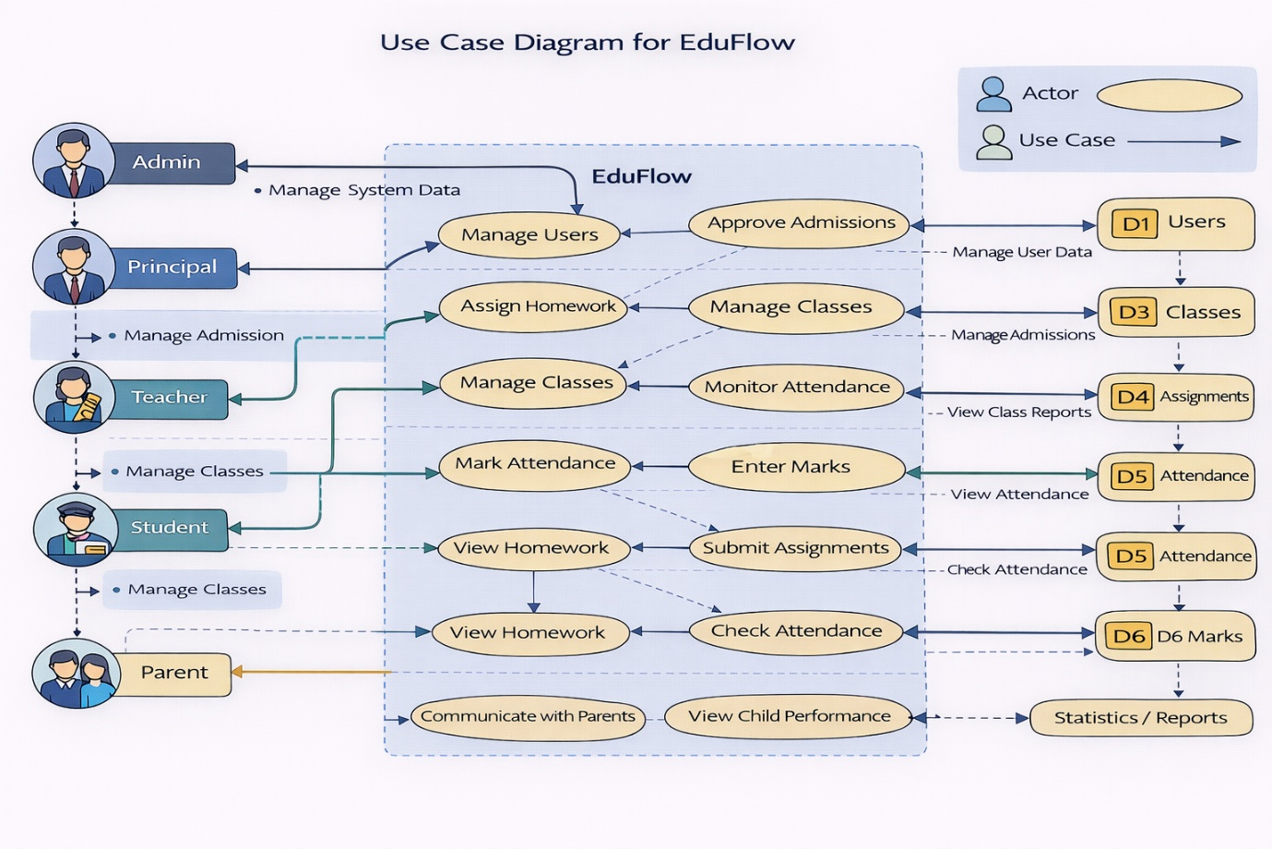

SCREEN LAYOUTS

9. SCREEN LAYOUTS
This section describes the user interface structure of each major screen in the EduFlow ERP system. The interface is designed using Bootstrap 5 to ensure responsiveness, clarity, and ease of navigation.
9.1 LOGIN PAGE
Purpose
The Login Page provides secure access to the EduFlow ERP system for all user roles including Admin, Principal, Teacher, Student, and Parent.
Interface Components
- Email input field
- Password input field
- Login button
- System header (EduFlow branding)
Functional Description
- Users enter registered email and password credentials. Upon clicking the Login button:
- Credentials are validated using Django authentication
- Role is retrieved from MySQL database
- User is redirected to role-specific dashboard
Security Controls
- Password encryption using Django hashing
- CSRF protection enabled
- Session management activated after successful login
Database Interaction
Validates against User table.
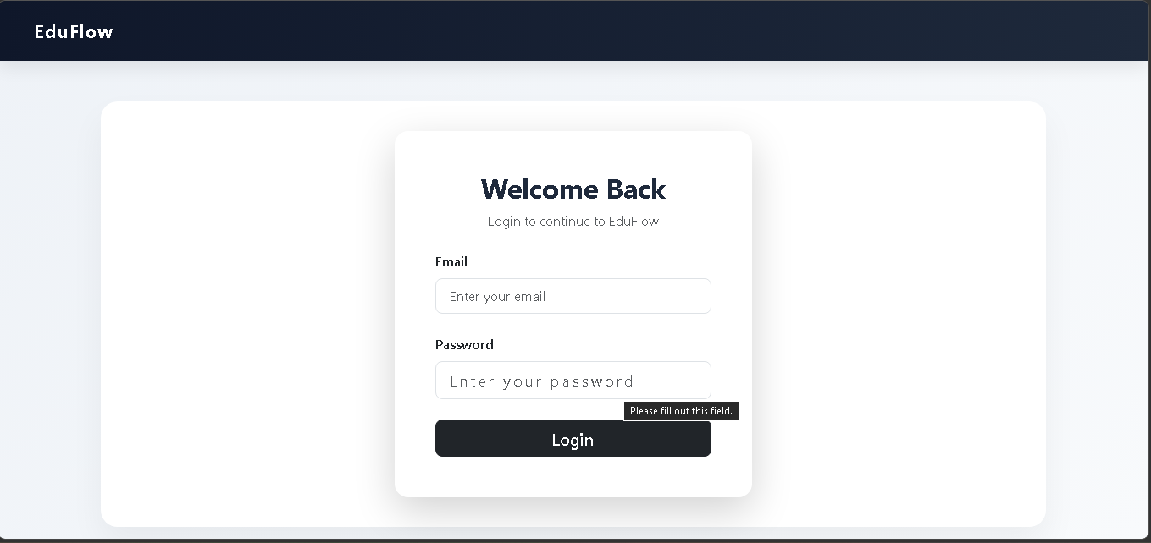
9.2 DJANGO ADMIN PANEL
Purpose
The Django Administration Panel is used by system administrators for backend database management.
Modules Visible
- Admission Applications
- Attendance Records
- Classes
- Exams
- Homework
- Marks
- Students
- Subjects
- Teacher Assignments
Functional Description
Admin can:
- Add new records
- Modify existing data
- Delete records
- View recent system activities
This interface directly interacts with MySQL through Django ORM.
Access Level
Restricted to Admin only.
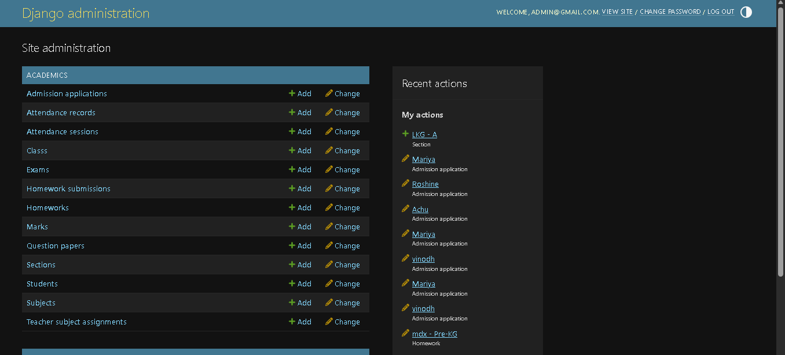
9.3 PRINCIPAL DASHBOARD
Purpose
Provides institutional-level academic monitoring.
Key Components
- Manage Classes button
- View Reports button
- Total Students count
- Total Teachers count
- Total Classes count
- Attendance Percentage
- Admission Status Summary (Approved, Pending, Rejected)
- Admission Applications Table
Functional Description
Principal can:
- Monitor academic statistics
- Approve or reject admissions
- View institutional performance
- Track attendance
Database Tables Used
- User
- AdmissionApplication
- Attendance
- Homework
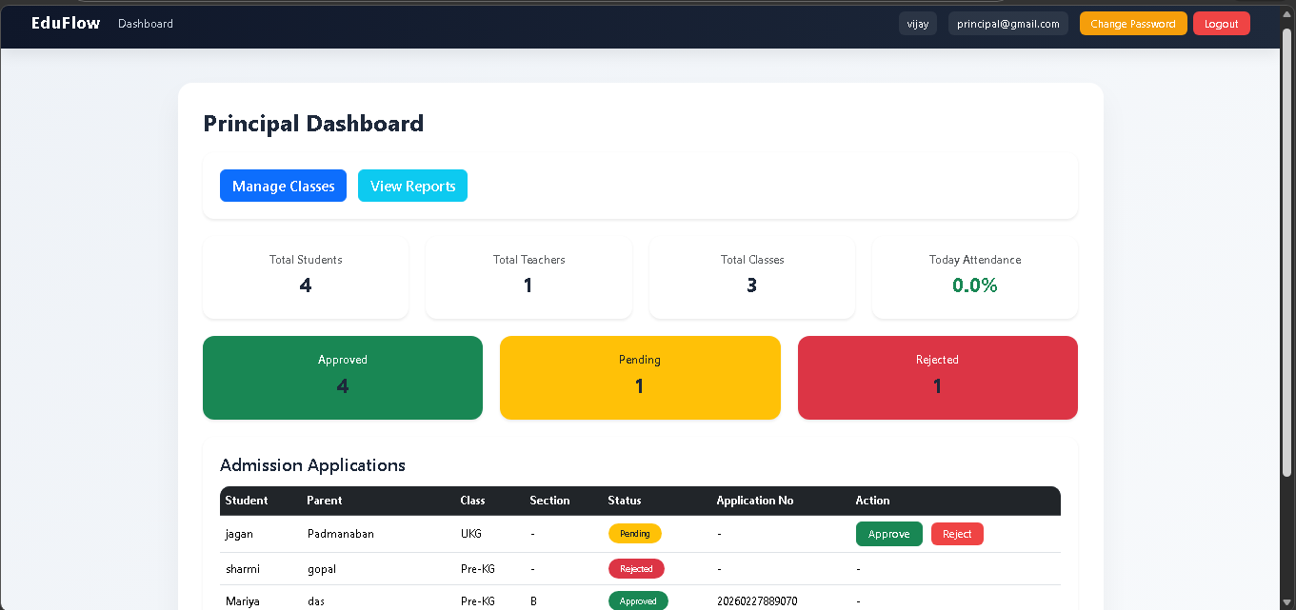
9.4 TEACHER DASHBOARD
Purpose
Allows teachers to manage academic responsibilities.
Key Components
- Assigned Subjects display
- Quick Action buttons
- Mark Attendance
- Enter Marks
- Upload Homework
Functional Description
Teacher can:
- Record attendance
- Enter exam marks
- Create and upload homework
- View student submissions
Database Tables Used
- Homework
- Submission
- Marks
- Attendance
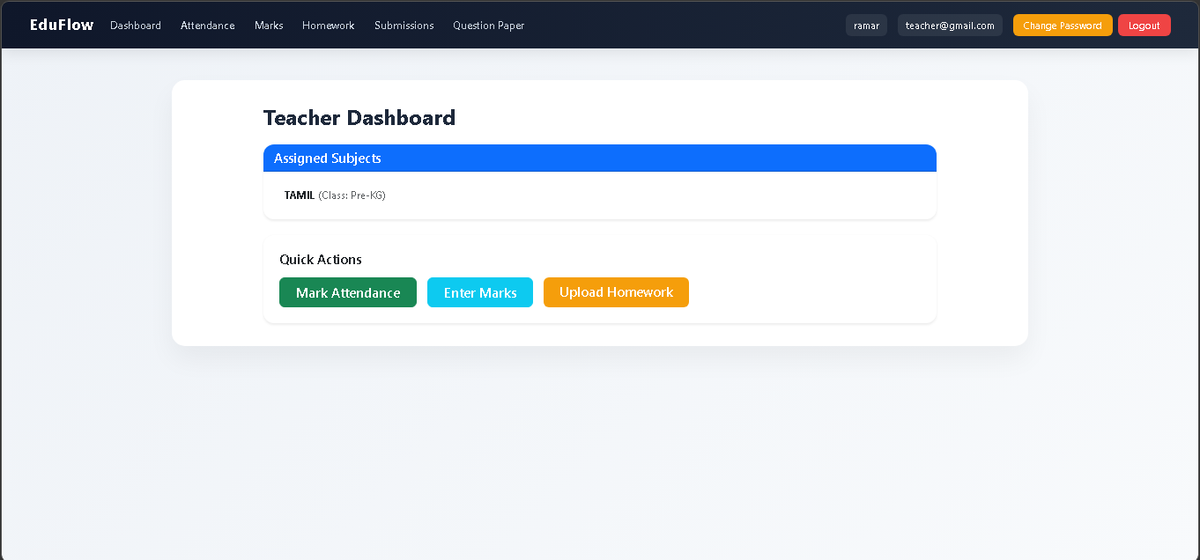
9.5 STUDENT DASHBOARD
Purpose
Displays personal academic information for students.
Key Components
- Student profile details
- Attendance percentage
- Average marks
- Marks details table
Functional Description
Student can:
- View attendance statistics
- View subject-wise marks
- Monitor academic progress
Database Tables Used
- Attendance
- Marks
- User
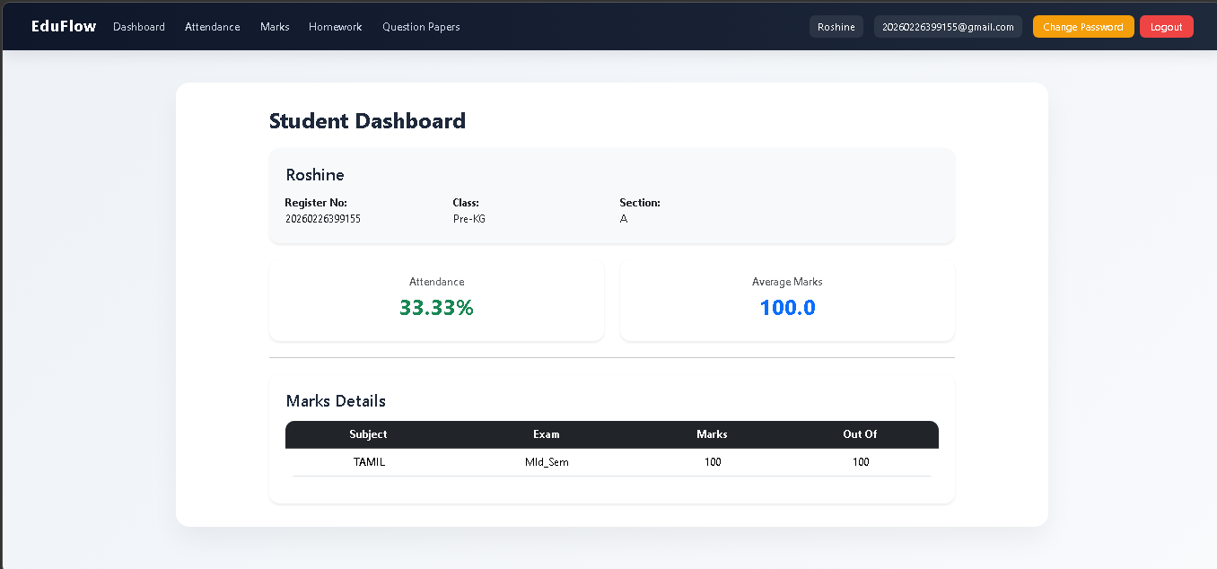

9.6 PARENT DASHBOARD
Purpose
Allows parents to monitor their child’s academic performance.
Key Components
- Child details
- Attendance percentage
- Average marks
- Attendance alert notification
- Recent homework list
Functional Description
Parent can:
- View child’s attendance
- View academic performance
- Monitor homework deadlines
Access Level
Read-only access. No modification privileges.
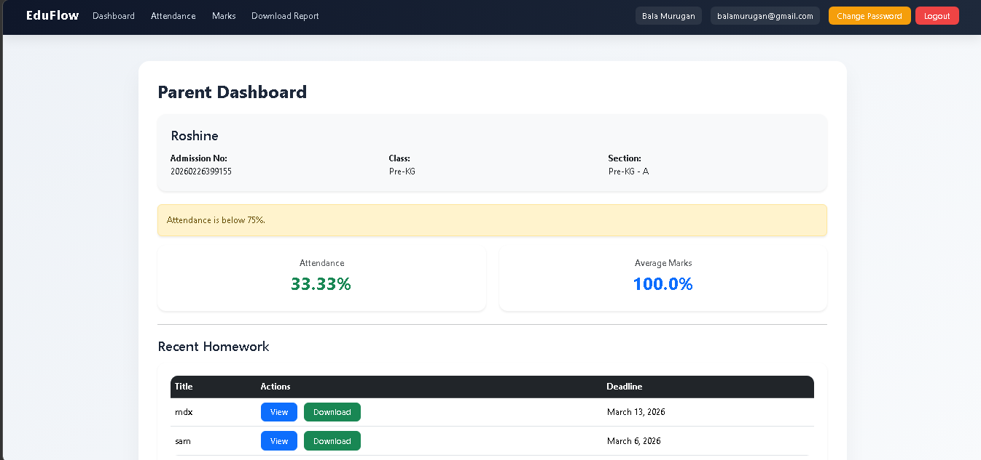
9.7 UPLOAD HOMEWORK PAGE (Teacher)
Purpose
Enables teachers to create and upload homework assignments.
Key Components
- Assigned Class dropdown
- Homework Title input
- Due Date selector
- File upload option
- Uploaded homework table
- Edit and Delete buttons
Functional Description
Teacher enters assignment details and uploads file.
System:
- Stores file in media directory
- Saves file path in MySQL
- Links homework to teacher
Database Tables Used
- Homework
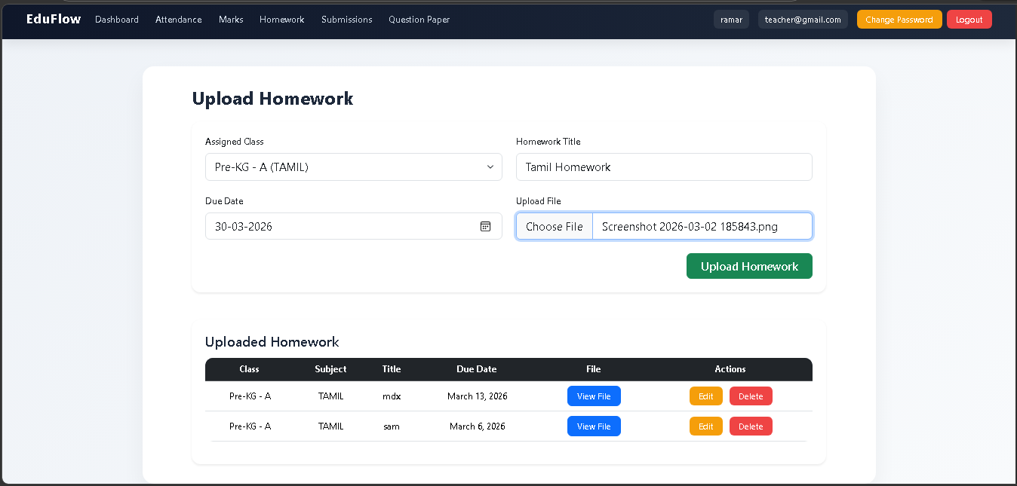
9.8 SUBMIT HOMEWORK PAGE (Student)
Purpose
Allows students to submit assignments digitally.
Key Components
- Homework title display
- File upload option
- Upload button
Functional Description
Student uploads assignment file. System:
- Stores file in media folder
- Saves submission record in MySQL
- Links submission to homework and student
Database Tables Used
- Submission
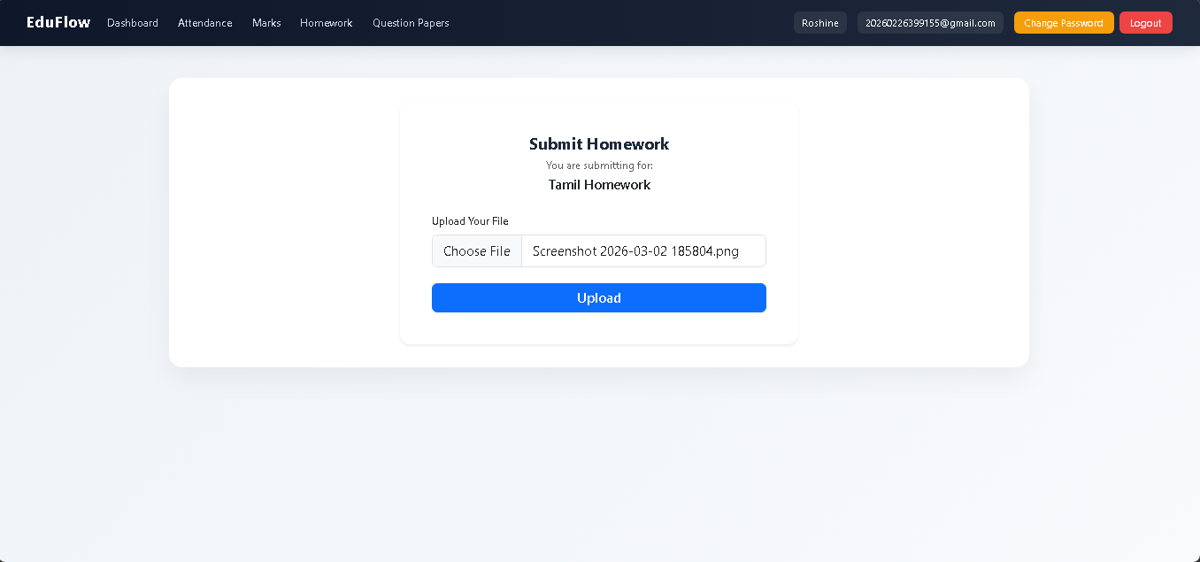

TESTING AND VALIDATION

10. TESTING AND VALIDATION
Testing ensures that the EduFlow ERP system functions correctly, securely, and efficiently under different scenarios. The system was tested at multiple levels to verify functional accuracy and performance stability.
Testing Types Performed
- Unit Testing
- Integration Testing
- System Testing
- User Acceptance Testing
10.1 UNIT TESTING
Unit testing was performed on individual modules to verify correctness of isolated components.
Modules Tested
- Login authentication
- Homework creation
- Assignment submission
- Admission approval
- Attendance marking
- Marks entry
Example Test Case
Test Case ID: UT-01
Module: Login
Input: Valid email and password
Expected Output: Redirect to role-based dashboard
Result: Passed
Test Case ID: UT-02
Module: Homework Upload
Input: Valid homework details and file
Expected Output: Homework stored in database and file saved in media folder
Result: Passed
10.2 INTEGRATION TESTING
Integration testing ensures proper communication between modules.
Scenarios Tested
- Teacher uploads homework → Student views homework
- Student submits assignment → Teacher views submission
- Admin approves admission → Principal dashboard updates statistics
Expected Behavior
- Database updates reflected across dashboards
- No data inconsistency
- Role-based access maintained
Result: All modules integrated successfully.
10.3 SYSTEM TESTING
System testing evaluates the complete application as a whole.
Areas Tested
- Authentication system
- Role-based redirection
- File upload and download
- Dashboard statistics
- Database operations
- Error handling
Performance Testing
- Multiple user login simulation
- Data retrieval speed testing
- File upload handling under normal load
Security Testing
- Unauthorized URL access attempts
- Role permission validation
- Session expiration testing
All security validations passed successfully.
10.4 USER ACCEPTANCE TESTING
User Acceptance Testing was conducted to verify system usability.
Users Involved
- Admin
- Principal
- Teacher
- Student
- Parent
Feedback Summary
- Interface is user-friendly
- Navigation is clear
- Homework tracking is efficient
- Dashboard statistics are informative
The system met user requirements and was approved for deployment.
10.5 SAMPLE TEST CASE TABLE
Test Case ID | Module | Input | Expected Output | Result
TC-01 | Login | Valid credentials | Dashboard loaded | Pass
TC-02 | Admission | Approve request | Status updated | Pass
TC-03 | Homework | Upload file | File stored | Pass
TC-04 | Submission | Submit file | Submission recorded | Pass
TC-05 | Attendance | Mark present | Attendance updated | Pass
Conclusion of Testing
The EduFlow ERP system was tested across multiple levels and demonstrated functional correctness, data integrity, secure access control, and stable performance.

CONCLUSION

11. CONCLUSION
The EduFlow ERP system successfully demonstrates the implementation of a structured, web-based academic management platform designed to digitize institutional operations. The system integrates administrative, academic, and monitoring functionalities into a centralized architecture using Django and MySQL.
EduFlow addresses the limitations of traditional manual school management systems by introducing automation, role-based access control, and centralized data storage. The implementation of separate dashboards for Admin, Principal, Teacher, Student, and Parent ensures controlled access and operational clarity.
The system effectively manages:
- User authentication and authorization
- Admission processing
- Homework creation and submission
- Attendance recording
- Marks entry and performance tracking
- Academic monitoring
The use of the Model–View–Template architecture ensures modularity, maintainability, and scalability. MySQL provides structured relational data management with referential integrity and optimized query handling.
Security mechanisms such as encrypted password storage, CSRF protection, and role validation strengthen system reliability. File upload handling is securely integrated with database linkage to maintain structured assignment tracking.
Testing at multiple levels validated the system’s functionality, integration consistency, and user usability. The application performs efficiently under standard operational conditions and demonstrates scalability potential for institutional deployment.
EduFlow serves as a foundational framework for modernizing educational administration. The system can be further enhanced with additional modules such as fee management, SMS notifications, cloud hosting integration, and analytics reporting.
The project fulfills its objective of designing and implementing a comprehensive School ERP system that enhances efficiency, transparency, and academic coordination.

REFERENCES

12 REFERENCES
The following references were used during the design and development of the EduFlow ERP system:
- Django Software Foundation.
Django Documentation.
Available at: https://docs.djangoproject.com/
- MySQL Documentation.
Oracle Corporation.
Available at: https://dev.mysql.com/doc/
- Bootstrap Documentation.
Bootstrap 5 Official Guide.
Available at: https://getbootstrap.com/docs/5.0/
- Python Software Foundation.
Python Documentation.
Available at: https://docs.python.org/3/
- Pressman, R. S.
Software Engineering: A Practitioner’s Approach.
McGraw-Hill Education.
- Sommerville, I.
Software Engineering.
Pearson Education.
- Elmasri, R., Navathe, S. B.
Fundamentals of Database Systems.
Pearson Education.
- W3Schools.
HTML, CSS and Web Development Tutorials.
Available at: https://www.w3schools.com/

